ANALYSIS AND RECOMMENDATIONS ON FOOD WASTE AT GREENLEAF GROCERY
by (Name)
The Name of the Class (Course)
Professor (Tutor)
The Name of the School (University)
The Date

Section 1: Use of Excel in Statistical Data Analysis

1.1 Confidence Intervals
Confidence intervals give information on where the actual average food waste is or can be expected to be in Dairy and Bakery products. These intervals are useful to determine the accuracy of our sample mean and understand the spread of waste level.
- Dairy Products: The mean waste is 16.09 units, 95% confidence interval: (15.74, 16.44). This rather small range indicates that Dairy waste levels are stable throughout the samples.

- Bakery Products: The mean waste is 26.32 units, with 95% confidence interval being (25.42, 27.23). The broader interval indicates higher variability of waste levels could be expected, which can depend on many factors, including demand uncertainty or difference in the conditions of storage.

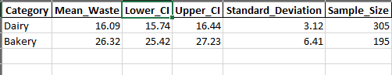
Figure 1 Confidence interval results
The practical implication of these findings is that any targeted intervention programs for Dairy products are likely to produce predictable results because the waste patterns are stable. However, the variability of Bakery waste requires additional investigation to explain why overstock and spoilage levels fluctuate so greatly between different time periods. By trying to balance these differences, Greenleaf can best determine how it can enhance its waste reduction programs for the two kinds of waste.

1.2 Hypotheses Formulation
Developing a hypothesis helps to make the evaluation of the conditions that have an impact on food waste systematic. For this analysis, we focus on two primary variables: shelf longevity and price.
Dairy Products:
- Null Hypothesis (H₀): Dairy waste quantities are not affected by Shelf longevity.
- Alternative Hypothesis (H_{a}): When shelf longevity is longer then the Dairy waste is reduced.
Bakery Products:
- Null Hypothesis (H₀): Bakery waste is not dependent on Price.
- Alternative Hypothesis (H_{a}): Higher price levels lead to more Bakery waste.
These hypotheses present the logical structure of the statistical analysis because they define how the main variables of interest are related to each other and how they affect waste levels. By testing these hypotheses, Greenleaf can determine which of these factors are most critical and which tactics are best suited to combating food waste at its source.

1.3 Correlation Analysis
Correlation analysis focuses on the relationship between two or more variables and the strength of this relationship. In this case, we look at the correlation between Shelf Longevity and Quantity Wasted by the customers on the Dairy and Bakery products.
Dairy Products: The correlation coefficient is -0.24. This means that the relationship is weak and negative. What this indicates is that longer shelf life means that dairy waste decreases slightly. This relationship, though small, suggest that the potential for extending shelf life can have positive effects on Dairy products.
Bakery Products: The correlation coefficient is 0.07. This indicates a positive though insignificant relationship between shelf longevity and waste. This suggests that shelf duration may not substantially affect Bakery waste. Other factors like prices may need to be explored to find out if they have an effect on bakery waste.
The correlation heat maps below illustrate these relationships visually:
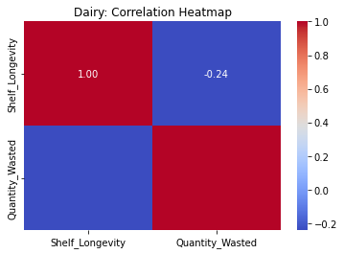
Figure 2 Dairy Correlation Heatmap:
Dairy Correlation Heatmap: Negative but weak is painted in cooler tones.
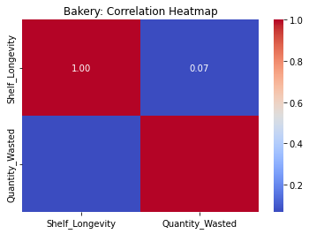
Figure 3 Bakery Correlation Heat map
Bakery Correlation Heatmap: This near zero coefficient seems neutral.
These heatmaps complement the interpretation of correlations, and also help Greenleaf to define the main areas that require intervention.

1.4 Simple Linear Regression
In order to take this analysis a step further, a simple linear regression model was then built to determine relationship between Shelf Longevity, and Dairy waste. The results were as follows:
- Slope (Coefficient): -0.32. This means that on average for every increased day of shelf longevity, Dairy waste reduces by 0.32 of a unit.
- Intercept: 17.58. Which is the initial amount of waste when the shelf life zero.

The following is the scatter plot with regression line, depicting Shelf Longevity and Waste for Dairy products — The negative relationship is indicated by the downward slope of the regression line, emphasizing the importance of shelf-life control.
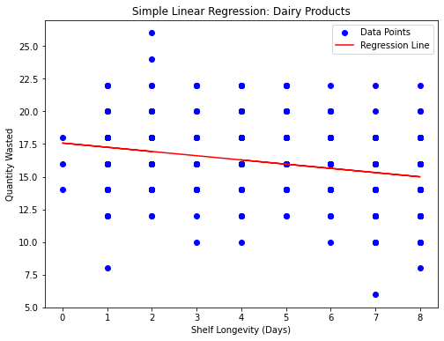
Figure 4 Simple Linear Regression: Dairy Products
As the regression points out shelf-life extension might lead to Dairy waste minimization, the negative slope indicates that other contributory factors such as inventory control and demand estimation, must be factored to minimize waste in the process.

1.5 Multiple Linear Regression
To establish the collective effect, a multiple linear regression of Price, Shelf Longevity, and Quantity Ordered was conducted. The results are summarized below:
Price: Coefficient =0.342. This shows that higher prices leads wastage. This might be due to reduced numbers of consumers buying the expensive products.
Shelf Longevity: Coefficient = -0.222. This shows that it has a waste reduction effect.
Quantity Ordered: Coefficient = 0.000, implying that this factor does not have any effect on waste.
Model Evaluation:
Mean Squared Error (MSE): 48.41 hence the model will have a moderate level of predictive accuracy.
Coefficient Table:
Feature | Coefficient
Price | 0.342
Shelf Longevity | -0.222
Quantity Ordered | 0.000

The outcomes therefore suggest the need for Greenleaf to incorporate pricing tactics and shelf life into the waste control plan. These findings indicate that although quantity ordered has no significant effect, price and shelf life have dominant impacts hence requiring comprehensive interventions.

Section 2: Ethical Dilemma Analysis using the 7-Step Framework

2.1 Analyzing the Context
The ethical issue involving Greenleaf Grocery is disposal of perishable foods that are close to expiring but are still good for human consumption. Greenleaf has to decide whether to dispose of substandard food items, which are still safe for human consumption or donate them to the needy Greenleaf Grocery.
Key stakeholders include:
- Customers: Being worried with food safety and quality.
- Employees: Desirable food waste management practices must be adopted.
- Local Community: Might benefit from donations yet they may be at risk
- Shareholders: Concerned with cost implications and company reputation

2.2 Assumptions and Worldviews
Key assumptions include:
- Donating expired food may have legal consequences
- Customers may have a negative view of expired food donations.
- Community members might accept expired but safe food
- Employees prioritize operational efficiency
- These assumptions need to be examined carefully to avoid biases.

2.3 Principles, Duties, and Care Needs
Greenleaf's ethical duties include:
- To Customers: Ensure food safety and transparency in making food products.
- To Employees: Better training and support should be offered
- To Community: Reduce the number of people suffering from food insecurity while ensuring safety.

2.4 Process, Outcomes, and Consequences
Available options for Greenleaf include:
- Donate food with stringent safety checks: May require capital investment but would be beneficial to society.
- Discount near-expiry items: Low wastage can be achieved though can be damaging to the brand.
- Dispose of unsold food: Lack of methodological complexity is another advantage of this approach, which, however, is ethically questionable.

2.5 Character Factors
Key virtues guiding decision-making include:
- Integrity: Ensuring food donations are safe
- Compassion: Addressing food insecurity in society
- Responsibility: Finding sustainable solutions to food insecurity.

2.6 Comprehensive Assessment
Donating food with safety Inspection is the most ethical decision as it satisfies stakeholders’ responsibilities, and eliminates chances of getting to the wrong side of the law. This approach also shows concerns of ethical practice and social responsibility by observed safety measures and interaction with the public.

Section 3: Analytical Problem-Solving

3.1 Overview of the Situation
Greenleaf Grocery’s issue of growing food waste some of which are contributed by the Dairy and the Bakery product divisions. This issue not only has operational and fiscal implications but also has values regarding well-disposed disposal and sustainable organization.
Key aspects of the situation include:
Nature of the Problem: Food that is not sold and is close to its ‘best before’ date is usually in position to become a major statistic in the food waste. In Dairy branch, generally, waste rates are stable and not too high, contrary to the Bakery branch where waste rates are much more volatile, probably because of irregular consumers’ markets.
Key Insights from Analysis
It was possible to deduce from the statistical analysis the findings; shelf longevity influences reduction of Dairy waste but little on Bakery. Moreover, it was found that availability and pricing of products affects the disposal of waste, thus suggesting that there is misfit between pricing and demand.
Ethical Considerations: Greenleaf therefore has to decide whether to donate near expiring or expired foodstuffs which are still fit for consumption. For this Green Leaf management has to factor in legal, reputation, and ethical issues.
Proposed Resolution: Solutions to these problems require operational, financial, and ethical strategies that are harmonized. Waste elimination requires that solutions address the sources while at the same time being fair and sustainable.

3.2 Solution Recommendations
Based on the findings, the following recommendations are proposed to address food waste effectively:
Implement Shelf-Life Extension Practices
Rationale: The analysis shows that extending shelf longevity has a significant impact on reducing Dairy waste. For Bakery, while the effect of shelf longevity is weaker, better storage conditions and supply chain efficiencies could stabilize variability in waste levels.
Actions:
Collaborate with suppliers to optimize storage and transportation processes.
Invest in advanced refrigeration technologies to maintain product freshness for longer.
Regularly review and adjust supplier agreements to prioritize longer shelf-life products.
- Impact: This approach will cut waste directly because products with long durations of usability will be made, especially those in the Dairy category.

3.3 Assumptions and Limitations
Assumptions
- Customers are ready to buy near expiry products at cheaper prices
- Local charities can manage the distribution of food that has been donated in the right way
- Across the various time period, the correlations, as well as the regression, results are comparable
Limitations
- Bakery waste has some variations and may need more research.
- The training cost and the cost of implementing new technologies may be more than estimated at the initial stage.
- Economic conditions could be used to explain how other aspects of pricing might work or not.
Overcoming the mentioned assumptions and limitations is imperative for improving the company’s planning and increasing the value congruency between strategic plans and operational goals.

Conclusion
This detailed paper offers practical guidelines for altering food waste at Greenleaf Grocery by utilizing statistical concepts and ethical considerations. With extending the shelf life of products, using the dynamic pricing approach, and providing a magnificent food donation program, Greenleaf will be able to address the issue of waste while building the successful image of the socially oriented company. Overall, the savings from such changes will without doubt enhance organizational performance, and enhance internal and external stakeholder relations.

